**Product and Territory Analysis Report**

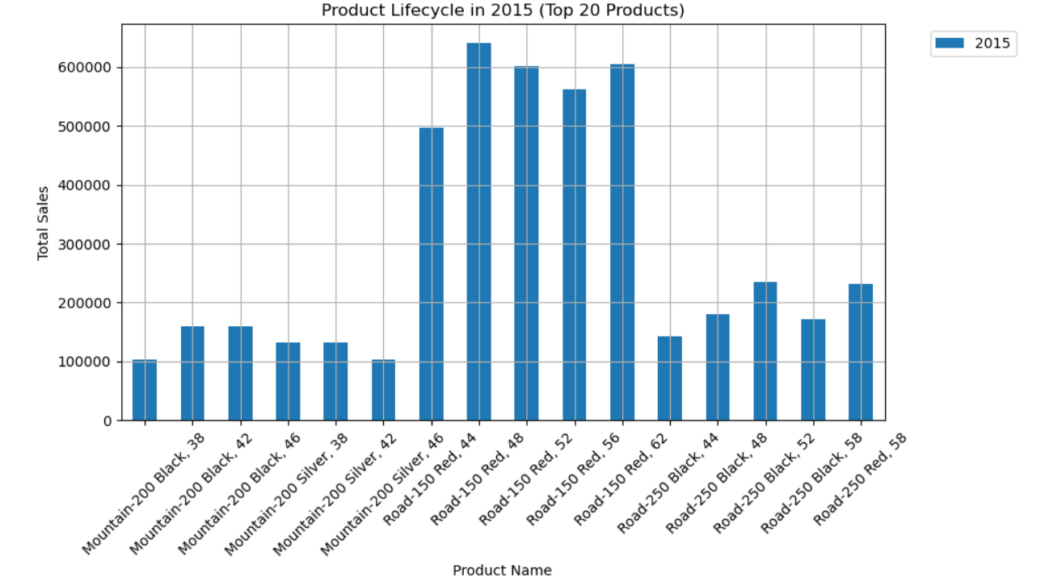

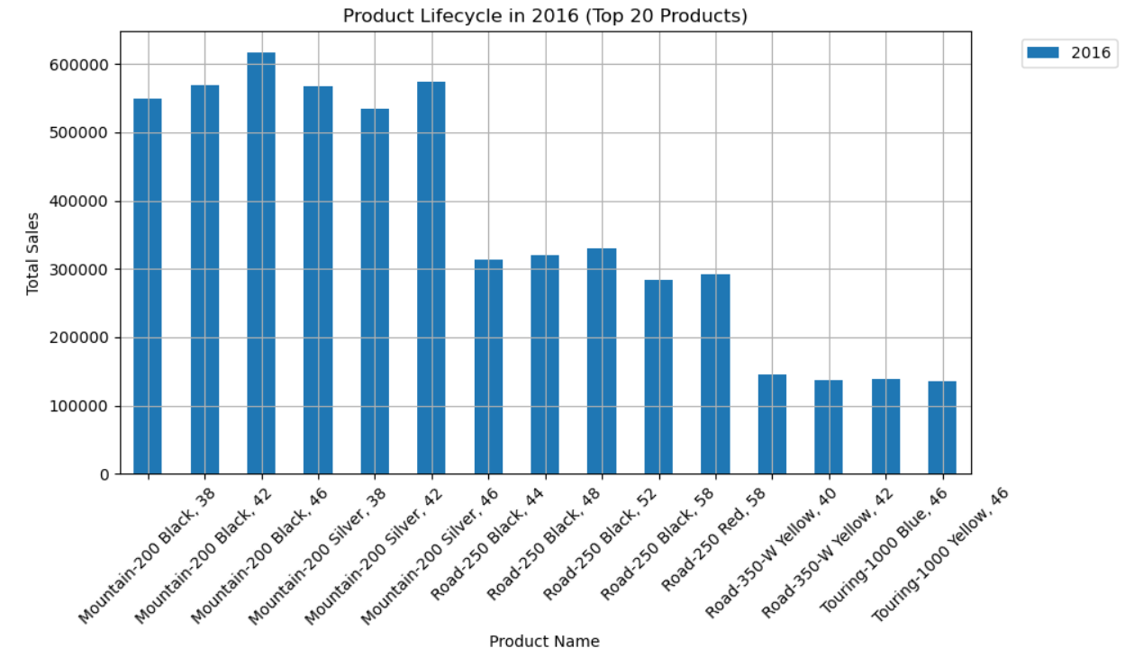

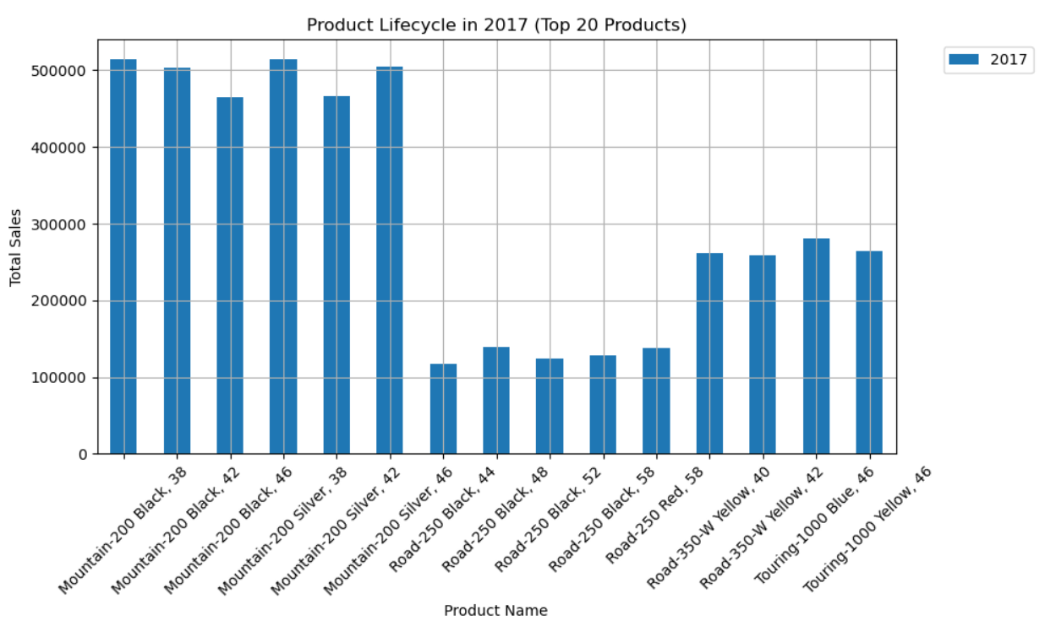

**1. Introduction**

This report analyzes the performance of various products and territories over the period from 2015 to 2017. The report focuses on metrics such as product lifecycle, sales trends, profitability, and territory performance. Additionally, the report evaluates external factors and their impact on product and territory sales.

**2. Product Analysis: Comprehensive Performance Metrics and Trends**

**2.1 Product Lifecycle Trends**

Over the years, several products showed consistent performance, while others experienced a lifecycle that peaked and then declined. The lifecycle analysis indicates:

* **Growth products**: These products, Mountain-200 Black, 38; Mountain-200 Black, 42, saw continuous growth in sales over the three-year period.
* **Mature products**: These products maintained steady sales without significant growth or decline.
* **Declining products**: Some products showed a drop in sales, suggesting they are in the decline phase of their lifecycle.

This insight is valuable for managing product portfolios and deciding which products to continue promoting and which to phase out.

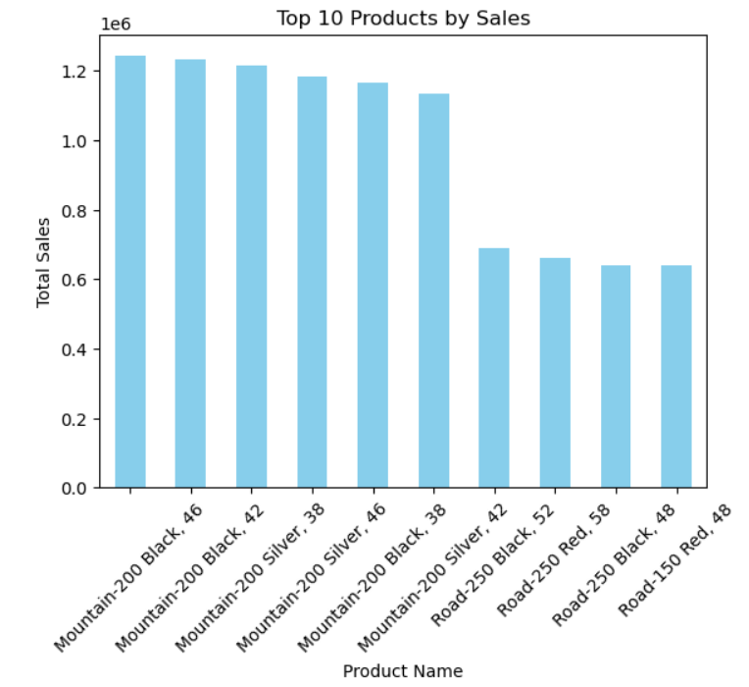

**2.1 Total Sales per Product**

The analysis identifies the top-performing products by total sales from 2015 to 2017. The majority of revenue is driven by a small group of products, reflecting the **80/20 rule** (where 80% of sales come from 20% of products). This indicates that focusing on the high-performing products can yield substantial gains.

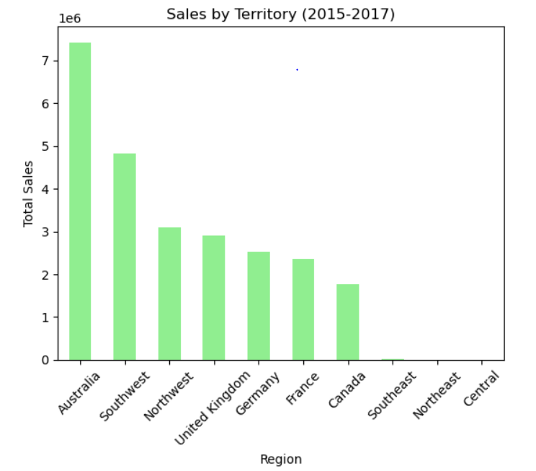

**3. Territory Analysis: Detailed Performance Comparisons**

**3.1 Total Sales by Territory**

The analysis of sales by territory highlights several key regions that contributed significantly to total revenue:

* **High-performing regions**: Certain regions such as Australia, being the highest performing region, followed by Southwest region, consistently outperformed others, accounting for the majority of sales.
* **Low-performing regions**: Regions such as the Southeast, Northeast and Central regions represent untapped potential and can be the focus of targeted marketing efforts to boost sales.

By focusing efforts on high-potential territories and evaluating the reasons for underperformance in other regions, sales strategies can be optimized.

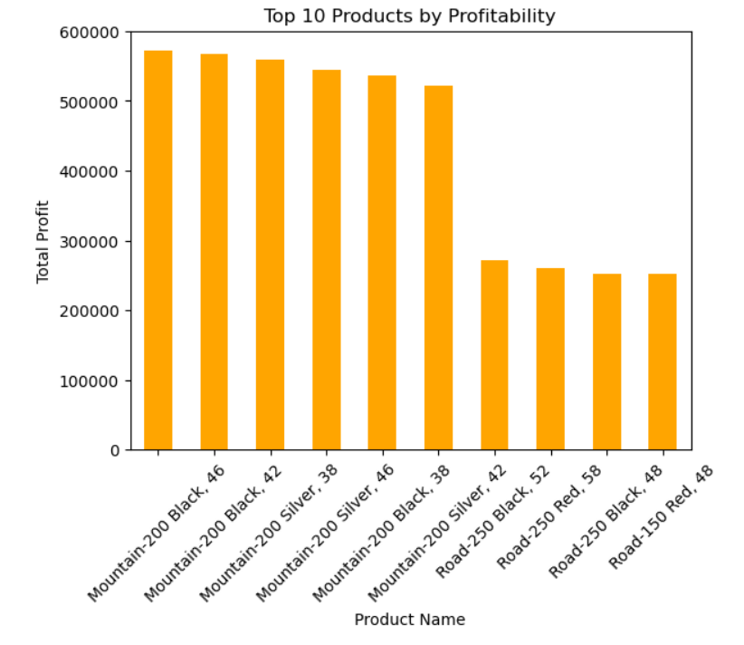

**2.3 Profitability Analysis**

The profitability analysis highlights the products with the highest profit margins. These products tend to not only generate substantial revenue but also produce significant profits, making them key drivers for the business.

Key insights:

* **Top 5 most profitable products** (Mountain-200 Black, 46; Mountain-200 Black, 42; Mountain-200 Sliver, 38; etc.) account for a large percentage of the company’s overall profitability.
* Products with lower costs but consistent sales volumes are particularly profitable.

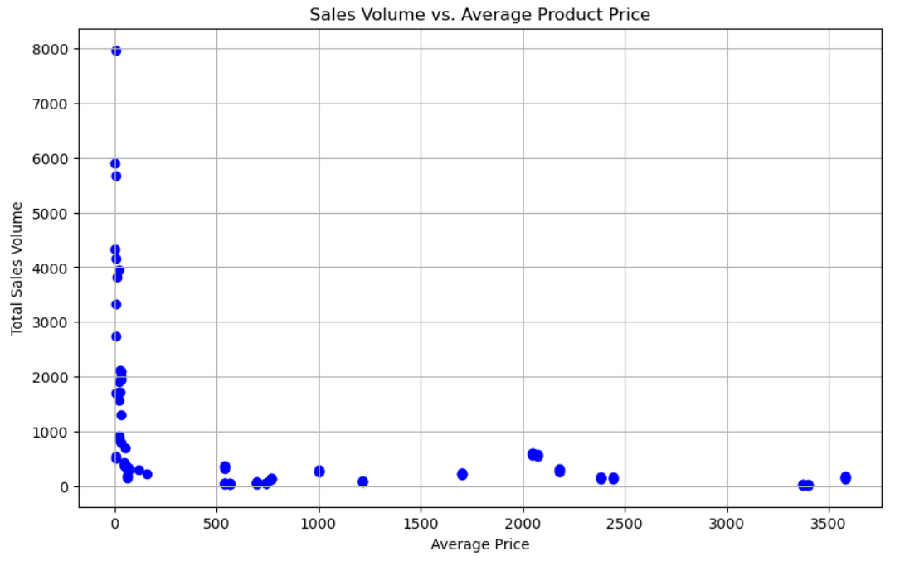

**2.4 Sales Volume vs. Price**

An analysis of sales volume versus product price shows:

* **Premium-priced products** tend to have lower sales volumes but higher overall profitability.
* **Lower-priced products** generate higher sales volumes, often contributing to total revenue but with lower profit margins.

The balance between volume and price is important in product strategy. Products priced appropriately for their target markets showed better long-term performance.

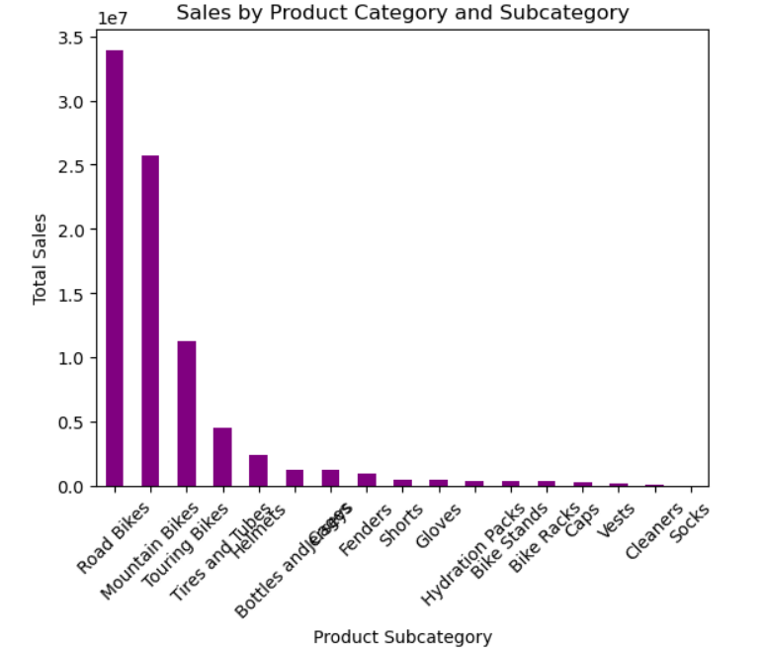

**3.2 Sales Distribution by Category**

Product categories and subcategories were analyzed to determine which categories contributed the most to total sales.

Road Bikes and Mountain Bikes subcategories contributed the most to total sales, while little or nothing was contributed by subcategories such as hydration packs, bike stands, bike racks, caps, vest, cleaners and socks

**4. External Factor Impact on Product Performance**

Marketing campaigns, promotions, and external economic factors are possible factors that could impact on certain products. For instance, Regions experiencing economic growth will see higher sales volumes. Also, Territories targeted with specific campaigns will show improvements in sales performance.

Understanding these factors helps in refining the marketing strategy to focus on regions that are more likely to respond positively to external stimuli.

**5. Conclusion**

This report highlights the critical products and territories that drive the majority of revenue and profitability. By focusing on high-performing products and optimizing efforts in high-potential territories, the business can continue to grow. Additionally, understanding the influence of external factors on sales performance allows for more effective strategic planning.